Odoo Field Service – Locations

Contents

What is a Location? 1

Location – Partner Relationship 1

Viewing Locations 1

Creating a Location 1

Convert Partner Record 1

Creating Sub Locations 1

Using the Sub Location Creation Wizard 1

# What is a Location?

Field Service Locations are any physical places that is serviced or supported by the company. Locations are owned by partners, can belong to territories, they are where field service workers can be sent to perform work, equipment (assets) can be tracked and managed, can be a distribution location (aka COLO), and can be setup in a hierarchy with child and parents. In addition to equipment; contacts, agreements, tickets and service orders are related to locations.

Some example locations:

* **Apartment Complex (MDU)**: Can contain sub locations for Buildings, Floors, Units, etc.
* **Residential House**: Might not have any sub locations.
* **Business (B2B)**: Could contain sub locations if related to parent.
* **Data Center**: Can contain sub locations for Rooms, Racks, Shelfs, etc.

# Location – Partner Relationship

Field Service Locations are an extension of the Partner (aka Contacts) module, therefore when a location is created, a related partner record is also created and directly linked to the location. Since the location module inherits the partner module, all fields on partner records are also available on the location therefore some are ‘shared’ across the records. For example, if the address changes on the location, the change is also automatically reflected on the partner record as this is a ‘shared’ or ‘related’ field. The same is for location tags and accounting information.

**Note**: A location will always have a directly related partner record, but not all partner records will have a related location record.

# Viewing Locations

Although locations maybe viewed in other apps, this document will focus on the Field Service App.

* In the **Field Service App**, go to **Master Data**, then **Locations.**

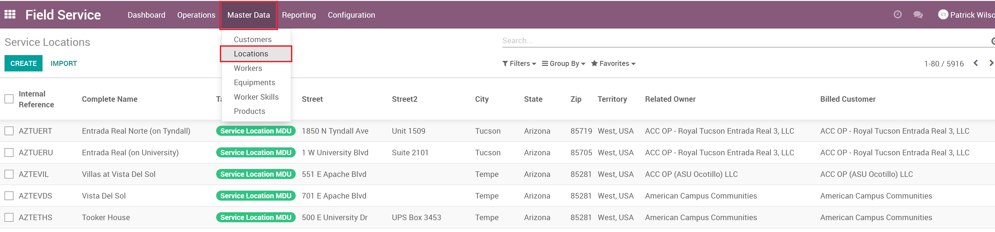

* The Locations list can be searched, filtered, grouped as needed.

# Creating a Location

Field Service Locations are best created via the Field Service App but can also be converted from the partner (aka Contact) if it was created before the location was.

* In the **Field Service App**, go to **Master Data**, then **Locations**.
* Click the **Create** button.
* Fill in all the required fields as well as other needed information.

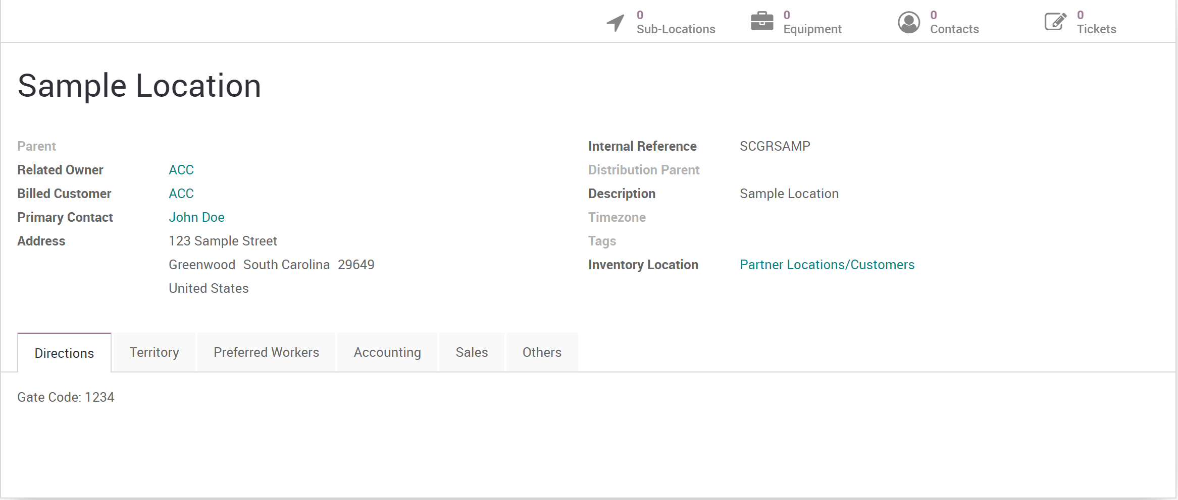

* Field Definitions
  + **Name**: The name of the location
  + **Parent**: If the location is a sub location, set the parent location.
  + **Related Owner**: The partner that owns the location.
  + **Billed Customer**: The billed partner that will receive the bill. **Note**: This could be the same as the owner, or a billing address of the owner.
  + **Primary Contact**: The individual who is the primary contact for the location.
  + **Address**: The physical address of the location.
  + **Internal Reference**: An internal reference for the location. **Note**: This is a unique field so multiple locations can not have the same internal reference.
  + **Distribution Parent**: If the location gets services from a distribution (aka COLO or Metro), this is where that info is set.
  + **Description**: Description of the location.
  + **Timezone**: The time zone the location is in.
  + **Tags**: Tags are used to categorize or set descriptive ‘tags’ on locations. Helps with searching, filtering and reporting.
  + **Inventory Location**: The inventory location that is used for inventory processes.
* Tab Definitions
  + **Directions**: Directions for the location used for workers or users. For example, gate information can be placed here or if the location has specific instructions for visitors.
  + **Territory**: The territory is used for organizing workers and managers.

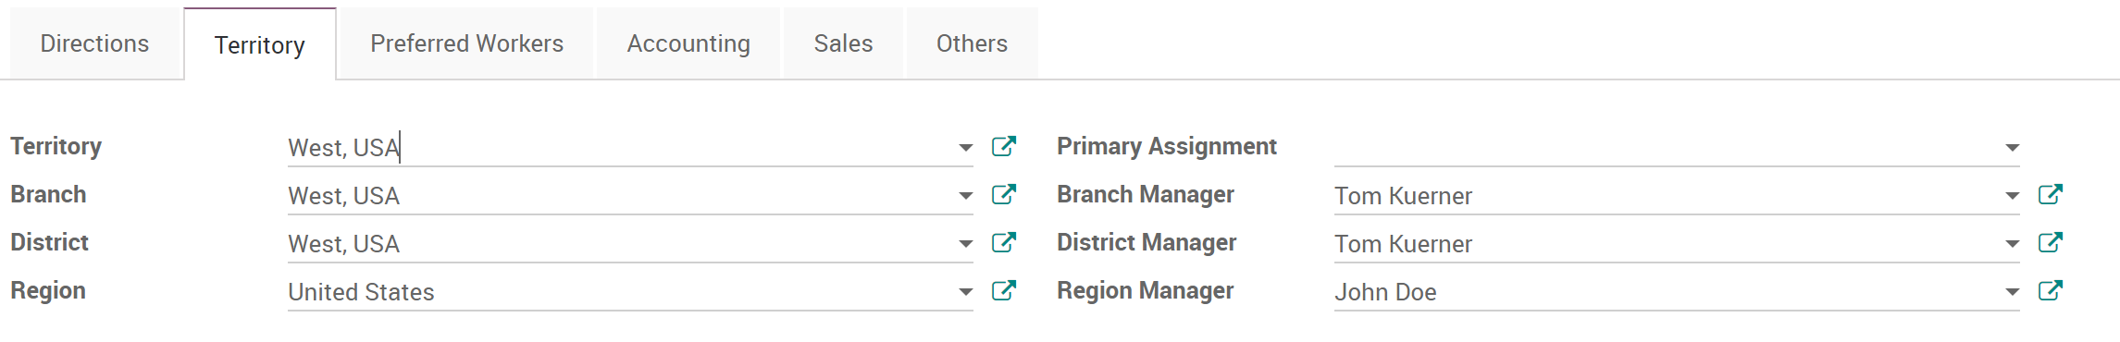

* + **Preferred Workers**: Lists the workers that are preferred to be sent to the site. Used during the dispatching process on field service orders.

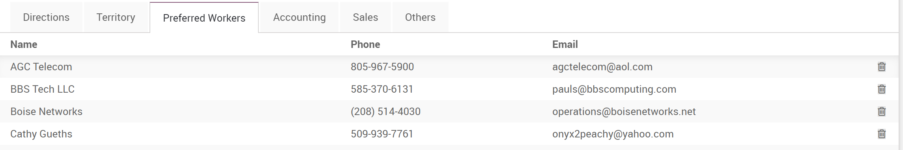

* + **Accounting**: Contains the analytic account for tracking accounting transactions involving this location.

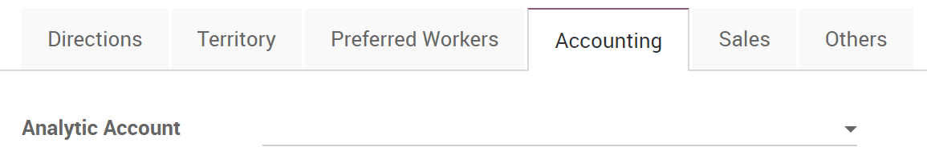

* + **Sales**: Sets the sales territory which salespersons might belong to.

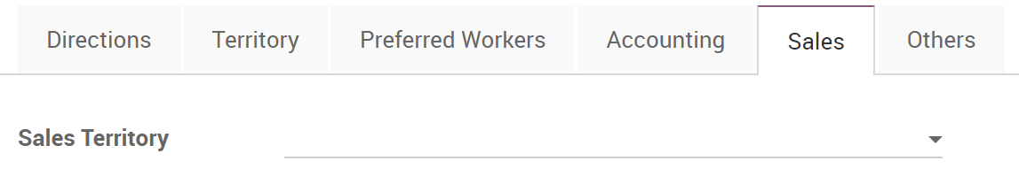

* + **Others**: Set the location as a distribution (aka COLO or Metro)

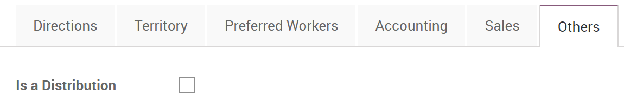

* Click the **Save** button to save the new location.

## Convert Partner Record

If a partner record already exists, it can be converted to a location.

* Open the partner record via the **Contacts App** or in the **Field Service App** (**Master Data**, **Customers**)

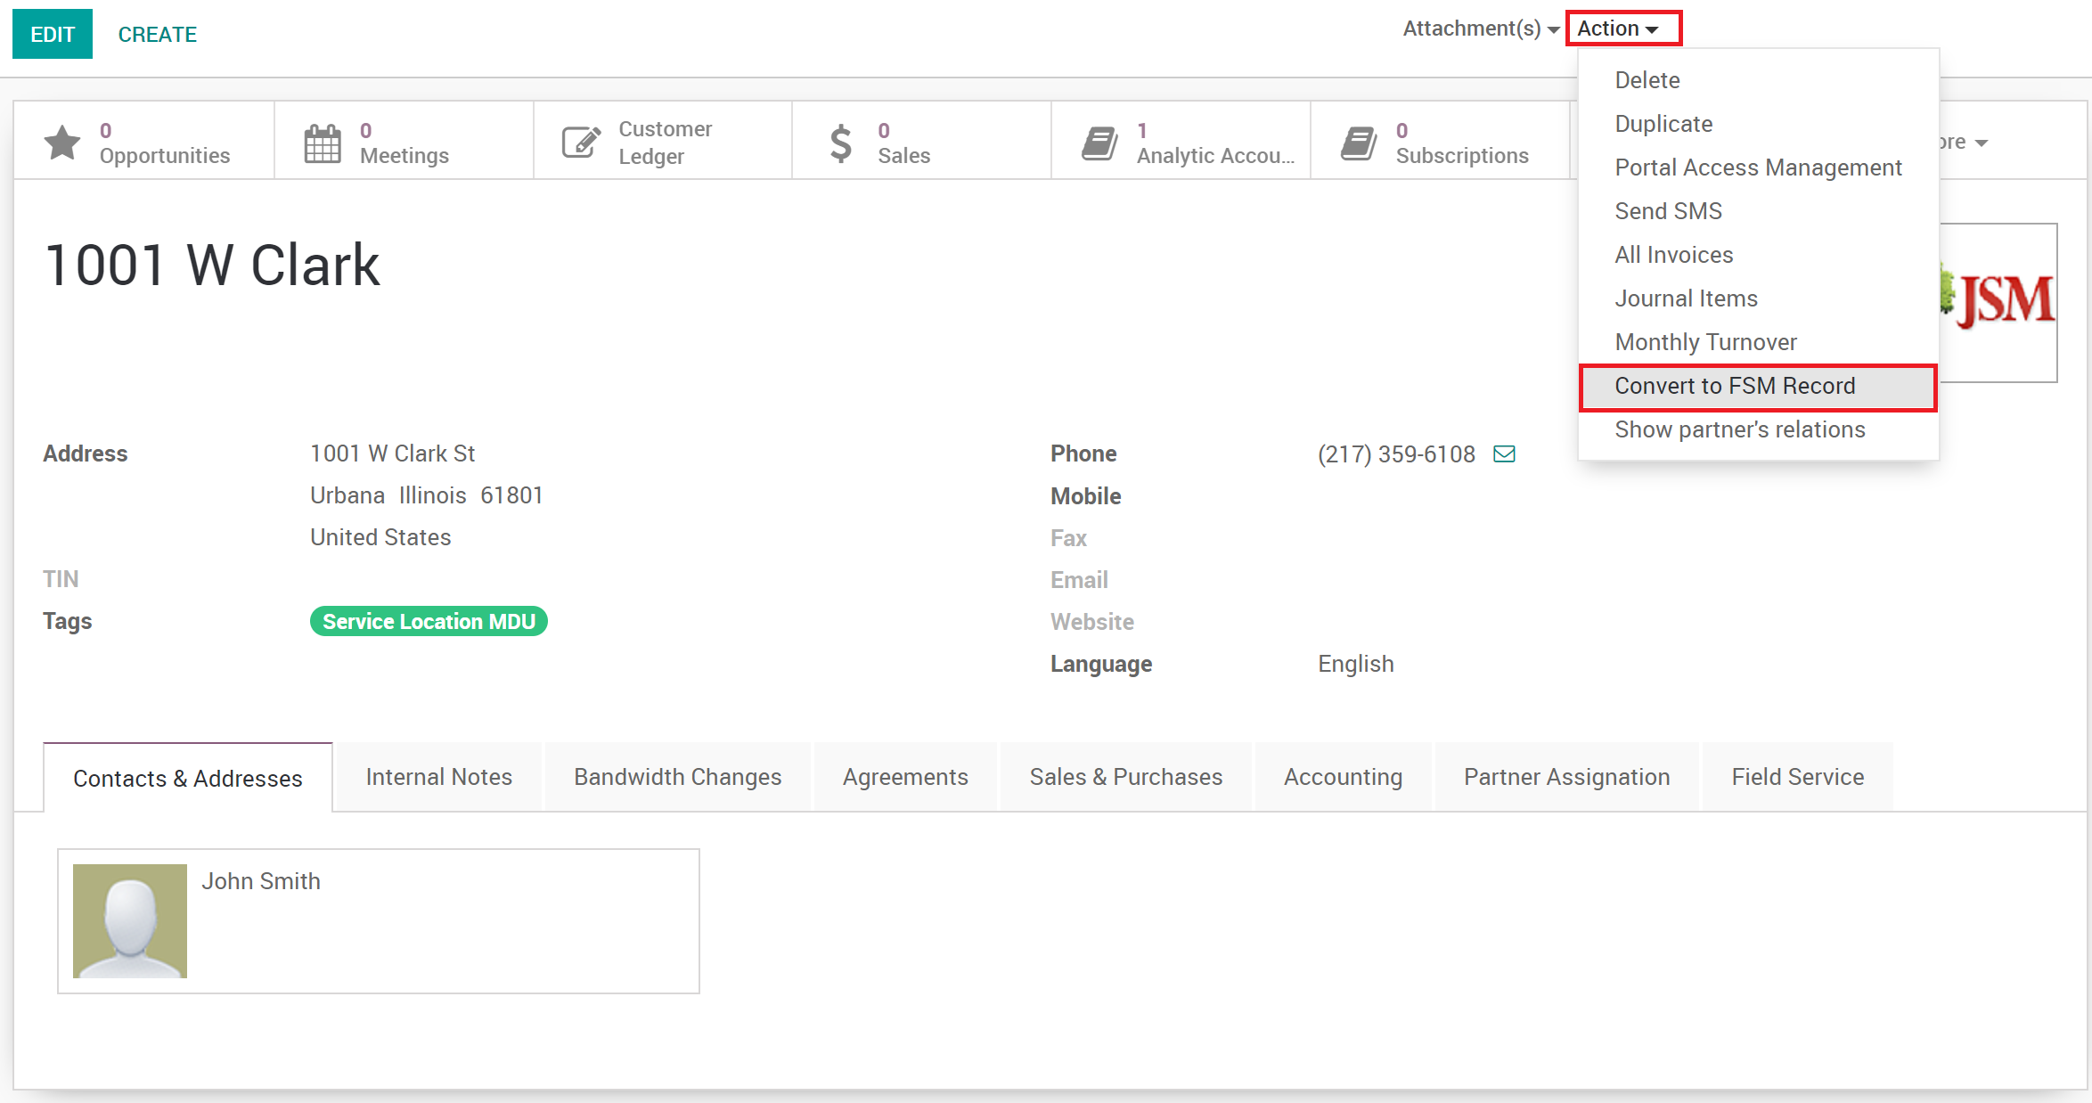

* In the **Actions** menu, select **Convert to FSM Record**.
* Select **Location** as the record type

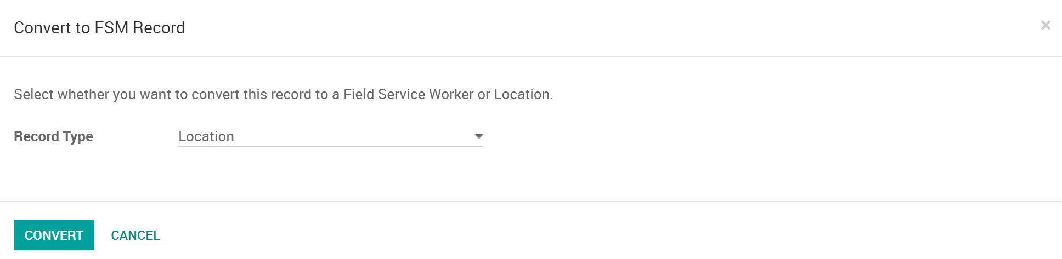

* Click the **Convert** button.
* The location will now be available. Update the newly converted location to complete the setup.

# Creating Sub Locations

Locations can be created in a hierarchy. Best practice is to create the sub location from the parent location. This will ensure that fields properly get mapped to the sub location and should speed up the process of creating the sub locations as fields will auto fill.

* Open the location you want to create sub location on.
* Click the **Sub-Locations** smart button.
* 
* Click the **Create** button.
* Fill in the fields of the location as you would creating a new location, making sure the parent field is properly set.
* Click **Save** to save the sub location.

**Note**: When opening any location, the Sub Locations smart button will count any child locations related to the currently viewed record. So if you open a parent location it will count and view all child locations of that parent. If you open a child location, it will then count anything linked below that record. This is called nested viewing.

**More Information**: Locations contain a ‘Complete Name’ field which is a compute field that shows the hierarchy directly in the name.

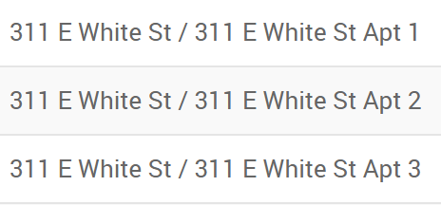

# Using the Sub Location Creation Wizard

The Sub Location Creation Wizard is being developed to easily create the sub locations in bulk. More information to come once available.